
Names: TELIMBERE Turamyeyezu Aime Christian Divin
ID :28828
PLSQL ASSIGNMENT

OVERVIEW:
Task 1: creating a pluggable database to be used in classwork
Task 2: creating another demo pluggable database to be deleted later
Task 3: configuring Oracle Enterprise Management

TASK 1:

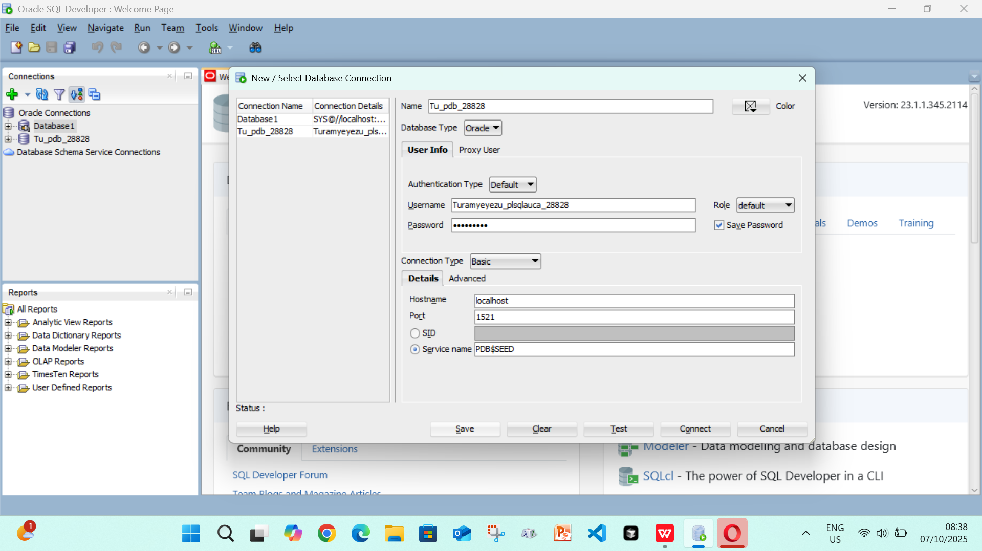

TASK 2:

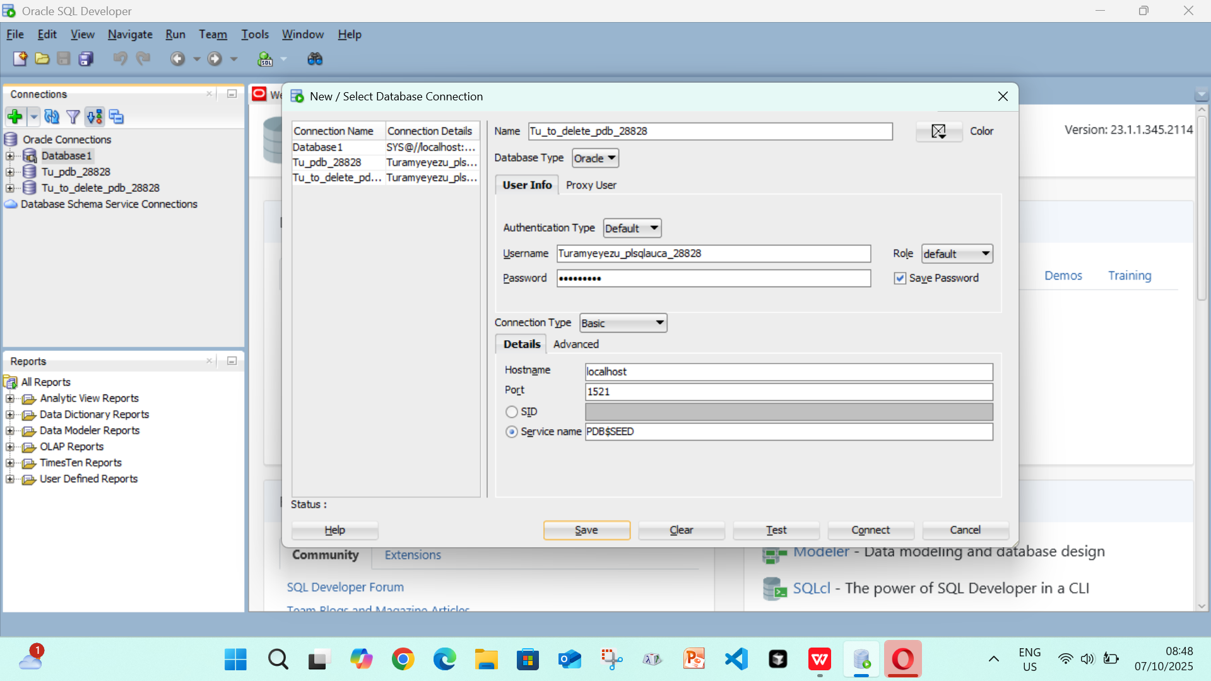

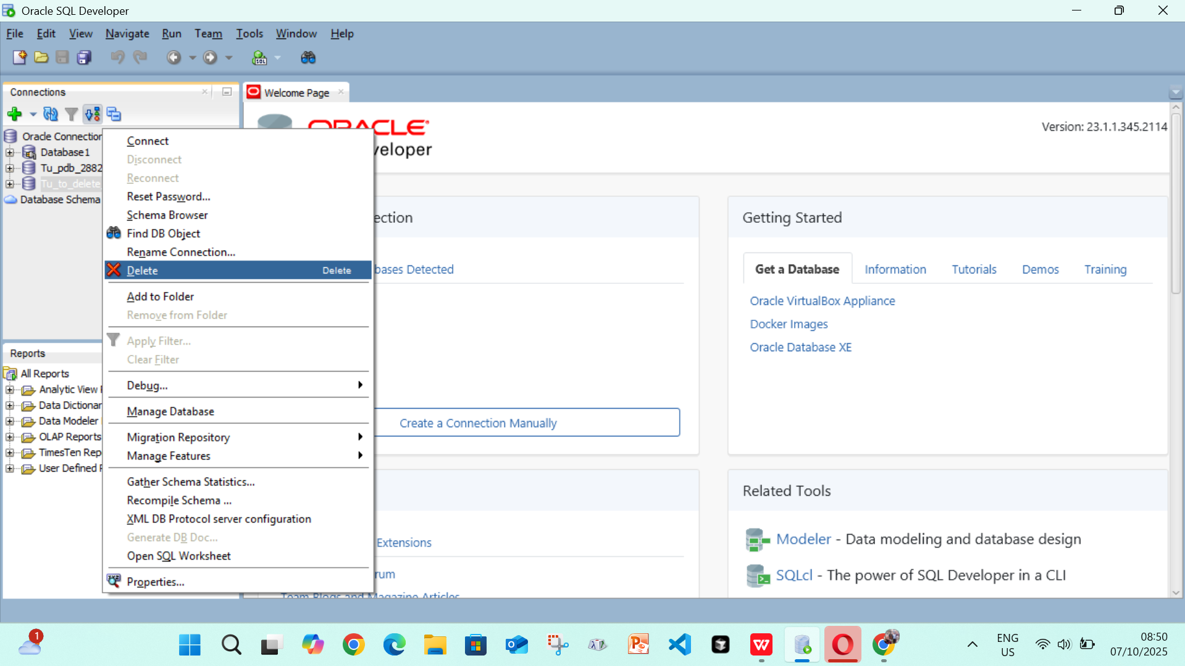

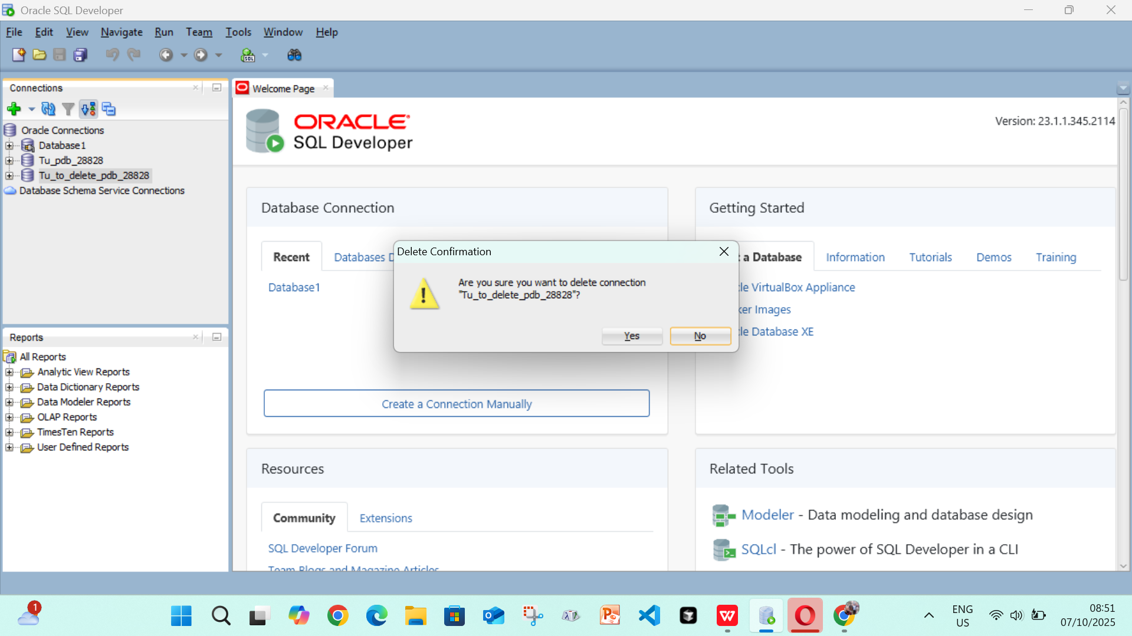

TASK 3: the self extraction of the installer to the drive has failed

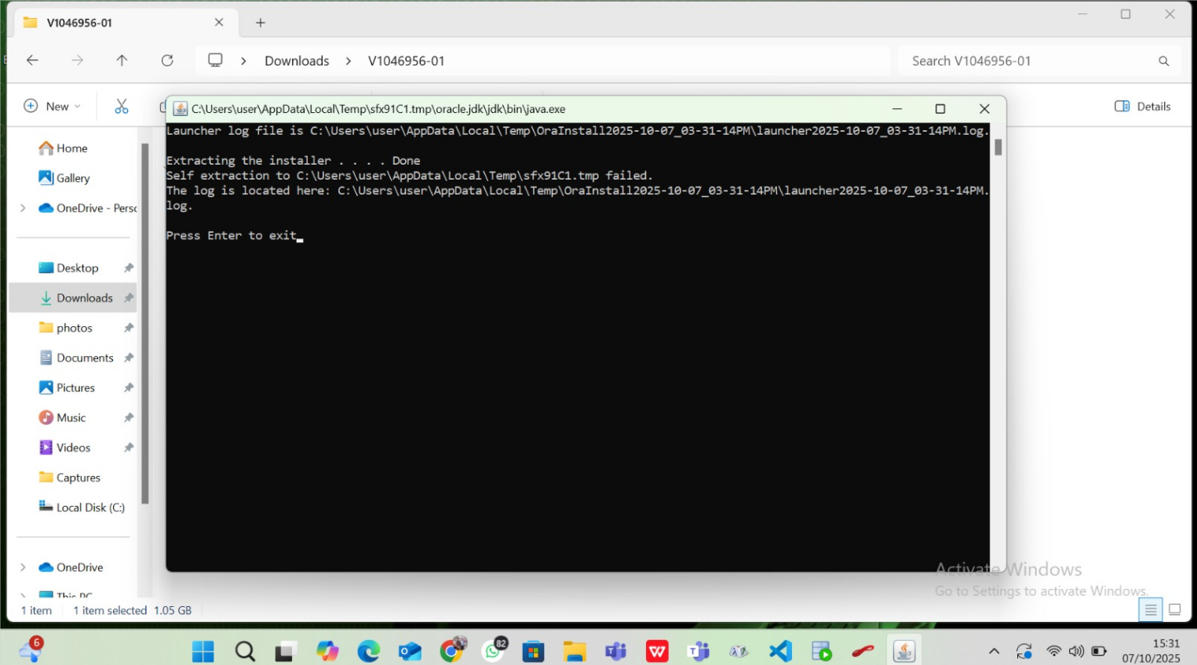

ISSUES ENCONTERED:
I encountered some errors which were quite difficult to solve like for example “Status : Failure -Test failed: Listener refused the connection with the following error: ORA-12514, TNS:listener does not currently know of service requested in connect descriptor (CONNECTION_ID=5W3dqYYKRBqGq+q4cMWFqg==)”
Which forced me to uninstall the database at some point and reinstall the newer version though the issue later resurged after the first succesful connection. And I think I might need some assistance from an experienced individual.

